Summary of Focus Groups for the Local Climate Adaptation Pilot for the Island Bay/Houghton Bay water catchment

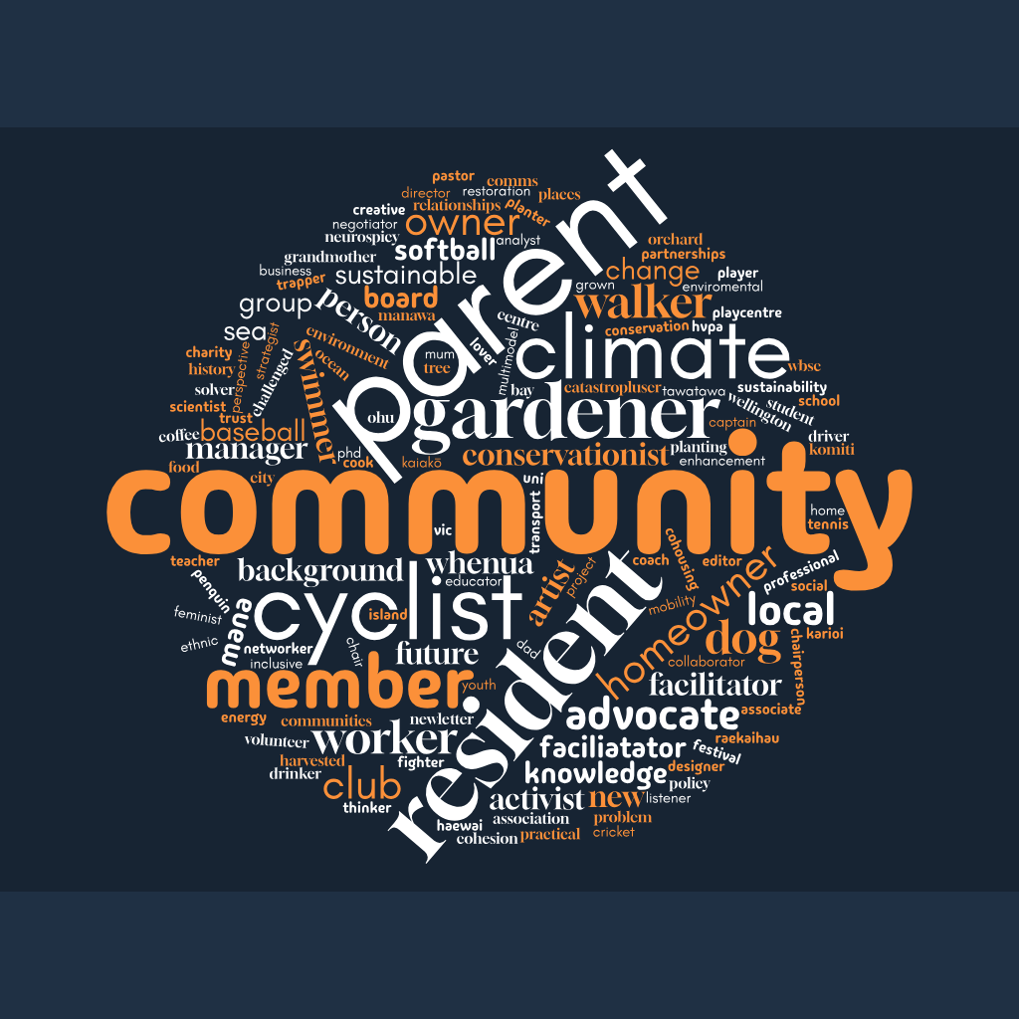

Prepared by: Clare Lundon Consulting
Date: 11 April 2025
Houghton Bay Focus Group 8 April 2025
The discussion centered on community engagement in Houghton Valley. Key points include:
Engagement and Relationships
- The group emphasised meaningful community engagement and relationship-building
- Houghton Valley has established strategies for working with mana whenua
- Participants expressed concerns about connecting this project with existing community initiatives
Vision and Approach
- Houghton Valley has a 100-year vision focused on environmental personhood for their catchment
- The local school has incorporated this vision into their strategic plan
- Participants stressed the need for a holistic approach that connects climate adaptation with mitigation
Community Building
- The group suggested creative engagement methods beyond traditional meetings (picnics, walks, postcards)
- Children's involvement was highlighted as particularly valuable
- Houghton Valley was described as having ideal characteristics for community building
Decision-Making and Governance
- Tensions were noted regarding decision-making authority between council and community
- Some participants suggested they might pursue parallel community-led initiatives if council constraints are too limiting
- Clarity was requested on existing rules and constraints
Integration
- Participants emphasised connecting geographic communities (coastline, landfill-affected areas)
- The group discussed integrating various environmental initiatives rather than working in silos
- Environmental personhood was described as a "game changer" that aligns with Te Ao Māori perspectives

Berhampore Focus Group 9 April 2025
This discussion about climate adaptation and community engagement, centered primarily on Berhampore and surrounding areas. Key themes include:
Community History and Connections
- Raewyn shared her family's history in the area since the 1950s, including Māori migration from rural areas to Island Bay
- Discussion of the Italian fishing community's historical presence and influence
- Participants have deep multi-generational ties to the area
- The Island Bay Softball and Baseball Club Logo - Mako Sharks represents both the local softball team and fishing heritage
- Chris Visser-Fee from the Island Bay Bowling Club has written the history of Island Bay
- Stormwater capture for sports field irrigation
Community Engagement Insights
- Relationships are crucial: "If they didn't have the relationships and the people in the clubs didn't respect them, it could have gone a whole lot worse"
- Example of the cycle lane project showed importance of relationship-building between council and community
- Different approaches for engaging youth were discussed, including working through schools and existing programs
- Owhiro Bay Stream Project about to start in a few weeks
- Large disability community – IDEA services supported living.
- Bryony Hales and the Community Noticeboard
Local Environmental Knowledge
- Discussions about underground streams and historical waterways beneath current development
Social Equity Considerations
- Discussion of socioeconomic diversity within the community and access barriers
- Understand the make up of this community
- Example of children who have never visited the beach despite living nearby
- Refugees and new residents who bring valuable perspectives on adaptation and change
- Importance of keeping programs and engagement accessible for all community members
The group emphasised that successful climate adaptation requires meeting people where they are, creating accessible engagement opportunities, and respecting the diverse needs of community members.
Island Bay Focus Group (1) 10 April 2025
This discussion about climate adaptation and community engagement, centered primarily on Island Bay and surrounding areas. Key themes include:
Climate Impact Concerns:
- Coastal flooding and sea level rise affecting Island Bay
- Repetitive flooding and land slips already occurring
- Storm water contamination in the marine reserve
- Some participants expressed scepticism about climate change evidence
Community Resilience:
- Discussion about emergency preparedness (water treatment locations, civil defence)
- Need for stronger community networks before disasters hit
- Importance of identifying vulnerable residents
- Using existing community hubs (schools, churches, sports clubs) as emergency centres
Communication Challenges:
- Many elderly residents don't engage with climate change information
- Disconnect between various community groups
- Need for multiple communication channels beyond digital
- Suggestion of street-level representatives to share information
Practical Solutions:
- Solar panels and emergency power generation
- Water storage tanks for households
- Waste management systems
- Community gardens for food security
Community Recommendations:
- Develop multiple communication strategies beyond digital platforms
- Create unified information sources for the community
- Support stronger connections between existing community groups
- Use events like the Island Bay Festival to bring groups together
- Implement street-level coordination for emergency preparedness
- Engage schools and youth in planning processes
- Leverage civil defence as a trusted information source
This group emphasised the tensions between immediate practical concerns and longer-term adaptation planning, as well as varying levels of climate awareness within the community, and levels of trust between Council and Community.

Island Bay Focus Group (2) 10 April 2025
This discussion about climate adaptation and community engagement, centred primarily on Island Bay and surrounding areas. Key themes include:
Community Engagement Approach
- The group emphasised the need for transparent, inclusive consultation that reaches beyond just the vocal minority
- Participants stressed the importance of making information accessible to diverse community members, including non-English speakers and those not on social media
- There was agreement that showing people concrete examples and visualisations of potential climate impacts would increase engagement
Balancing Different Interests
- Discussions highlighted the challenge of balancing different community interests while making decisions for collective benefit
- The group acknowledged that climate adaptation decisions will affect different people differently, making fairness and transparency crucial
Community Panel Proposal
- Participants suggested they would prefer to review options rather than start from scratch, emphasising the need for expert information and concrete proposals
Youth Engagement
- The group discussed strategies for involving young people, noting their strong interest in climate issues
- Participants mentioned connecting with schools, making engagement fun, and identifying youth champions
Cultural Diversity
- Representatives highlighted the need to engage with ethnic communities (about 20% of Wellington's population)
- Discussion of cultural barriers and the importance of collecting stories from immigrant communities who have experienced climate disasters and disruption.
Māori Partnership
- The importance of incorporating indigenous perspectives was acknowledged
Communication Preferences
- Participants expressed desire for visual presentations, data, and area profiles rather than abstract discussions
- The group suggested videos, interactive maps, and in-person presentations as effective communication tools
The session concluded with participants reflecting on the value of inclusive discussion and expressing commitment to sharing information with their wider communities.

