Meet the Candidates Night

Ask a question via Slido
Slido.com #4139247

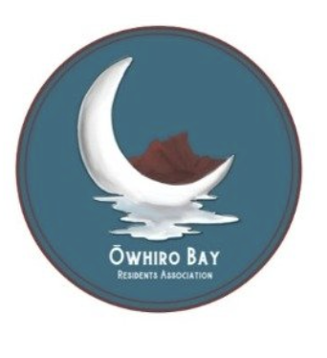


Thursday 25th August

Wellington South Baptist Church

7-9.30pm

Doors open at 6.30 pm and close at 10 pm

Join Zoom Meeting
https://us02web.zoom.us/j/82264002492?pwd=aWFkek1SaEdGR2NHY1J4dVM0c24rQT09
Meeting ID: 822 6400 2492. Passcode: 178414

Brought to you by Õwhiro Bay and Island Bay Residents’ Associations

Please wear a mask
7pm | Intro, housekeeping and H&S
7.10-8.10 | Mayoral candidates  Ellen Blake - Independent  Ray Chung - Independent  Chris Dudfield - Independent - Vision/Skills/Results (Mayor and Southern Ward)  Paul Eagle - Independent  Andy Foster - Together for Wellington  Donald Newtown McDonald - Our truth all but whole truth  Barbara McKenzie - Independent  Tory Whānau - Independent  Each candidate gets a 30s opener to introduce and say a little bit about themselves.  Each candidate will then get asked 4 questions. The first 2 are simple quick responses/icebreakers.  These will be followed by these 2 questions (max 90s to answer):  - How will you plan to accelerate council action on coastal adaptation to climate change, and more widely reduce our city's emissions?  - In 3 years, at the end of your term if elected, what will you have done to make this city better?  Candidates then get 90 seconds to ask us to vote for them.  Questions
8.10-8.30 | Mãori Ward - Same format as for mayoral  Ali Hamlin-Paenga  Matthew Reweti - Labour
8.30-9.35 | Southern Ward Candidates - Same format as for mayoral  Nureddin Abduraham - Labour  Inoke Afeaki - Independent  Dipak Bhana - Independent #Together for Wellington  Urmilla Bhana - Independent  Jonathan Coppard - Action on Climate  Laurie Foon - Green  Iain Alasdair MacLeod - Get Wellington back on course  Ate Moala - Independent  Paula Muollo - Independent

Tea and coffee are available throughout the evening and at the end for anyone who wants to stay and talk

