Roadworks in your area – Severn Street
What’s happening?
This is to advise you of upcoming maintenance work to the kerb, channel, footpath, road surface and handrails. This is to let you know that work will start soon.
WHERE | Severn Street, section between Frobisher Street/Robertson Street intersection and Owhiro Bay Parade
START | Monday 8th August, 2022
FINISH | Late November, 2022
WORK HOURS | Between 7am and 5pm

This work is weather dependant and in the event of unsuitable weather or other unforeseen circumstances, the work will possibly be delayed. You will be updated accordingly.
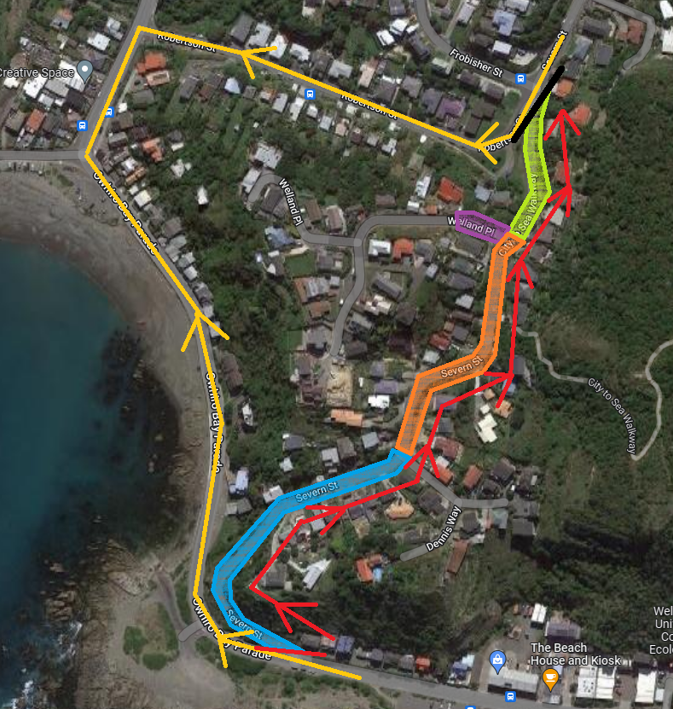
Map of work areas
GREEN ZONE – SECTION 1 WORK AREA, NO PARKING
PURPLE ZONE – SECTION 2, WELLAND PLACE WORK AREA, NO PARKING
ORANGE ZONE – SECTION 3 WORK AREA, NO PARKING
BLUE ZONE – SECTION 4 WORK AREA, NO PARKING
RED LINE – RESIDENTS ACCESS ONLY CLOSURE POINT and ONE WAY ACCESS
YELLOW LINE – NON- RESIDENTS DETOUR ROUTE
BLACK LINE – FULL CLOSURE POINT, NO TURNING INTO SEVERN STREET FROM FROBISHER/ROBERTSON INTERSECTION

*THE HIGHLIGTHED ZONES ARE ROUGH ESTIMATES ONLY. PLEASE ADHERE TO THE NO PARKING CONES THAT WILL BE DEPLOYED BEFORE WORK BEGINS*


Will we be back?
Yes, this work is in preparation for road resurfacing within the next 12 months.
Please ensure your vehicle is parked clear of the worksite.

To do this work we need the site to be clear of vehicles and other obstructions so parking will be affected. We will do our best to minimise disruption as much as possible but please ensure your vehicle is parked clear of the highlighted work area. If your vehicle is parked in the way we may have to tow it to a suitable park nearby. Should your vehicle be moved and not returned to its original location, please check nearby streets first before ringing the contractor listed on the reverse.
What access will be available during this time?

A no through traffic closure will be in place with only residents having vehicular access during work hours. Due to the already narrow nature of the road, one-way resident access will be in place 24 hours a day. Residents will need to enter from Owhiro Bay Parade as there will be no access from the Frobisher Street/Robertson Street intersection. This will all be accompanied by a reduced speed limit. Pedestrians and cyclists will still be able to use the route but please follow the directions of our crew when passing through the work site. The whole work site has been split into sections to minimise the impact on residents. A detour route for non-residents will be via Robertson Street.


Will these road works effect access to my property?

Residents and / or business owners will have access to their property but during phases of work you may experience some delays. In the case of an emergency, essential services will be given priority. If you are expecting a delivery or have a tradesperson needing access we will navigate them through the work site. Rubbish collection and recycling will continue as usual.
Will there be impact to bus services?
Bus services will not be impacted by this work and will run as usual.
Thank you
We know this work can be disruptive. We appreciate your cooperation, patience and understanding as we work to ensure our city’s roads are well looked after.

Contacts
If you have any questions or there is anything we need to be aware of, please contact:

Fulton Hogan
04 387 4852
wccsouth@fultonhogan.com

Wellington City Council
04 499 4444
info@wcc.govt.nz

