Roadworks in your area
Dear Resident,
This letter is to advise of the upcoming works in your area that has been devised by Wellington City Council and will be implemented by Fulton Hogan. Following the completion of the extensive water works, many sections of the road require resurfacing. In preparation for this, we need to update and improve various areas of kerb, channel, footpath, and carriageway so that no more planned maintenance work will need to be done during the life span of the new road surface. The goal is to leave you with a new road surface that will last for the next 10-15 years.
Unfortunately, several areas in the attached picture need serious attention. Starting in late July, we will have several crews working in your area leading up to the main resurfacing early in 2023. We are very aware that you have had to suffer through seemingly endless roadworks for the last couple of years and apologise for adding to that pain, but our required work won’t be as obstructive or as long as previous works.
Map of work areas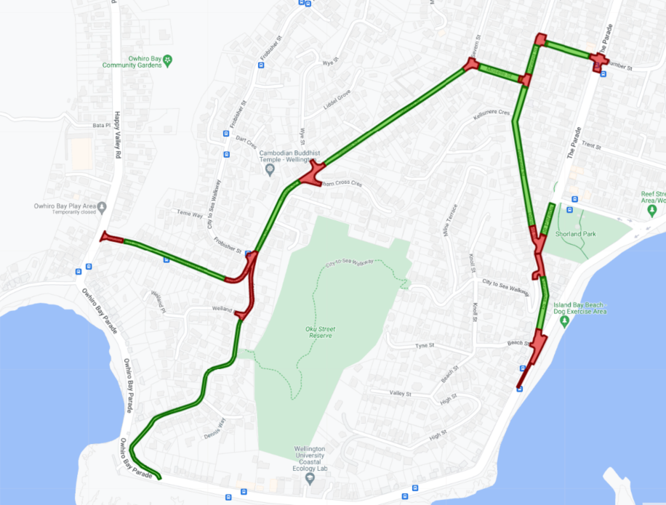
GREEN AREAS – CHIPSEAL ROADS
RED AREAS – ASPHALT INTERSECTIONS
Roberston Street, Severn Street [Owhiro Bay-Moselle], Moselle Street, Humber Street, and Derwent Street [Humber-Esplanade]

Each intersection in the highlighted area will be resurfaced using Asphalt Concrete [AC]. Asphalt is dark in colour consisting of bitumen and aggregate which is mixed off site. It is applied hot to the prepared road surface and compacted smooth by rolling. All roads in between will be chipseal. Chipseal is a texturized surface which involves spraying hot bitumen to the road surface, spreading aggregate (stone chips) and finished by rolling to embed the stone chips into the bitumen. Chipseal is a waterproofing layer that will preserve the structural integrity of the street for years to come.
The map overleaf indicates all areas that have been identified for resurfacing. This letter is designed to let you know that work will begin on Severn Street, at the intersection with Frobisher/Robertson, working towards Owhiro Bay Parade. A more specific communications letter will be sent out to directly affected residents closer to the start date. This will happen for each section of preparation work.

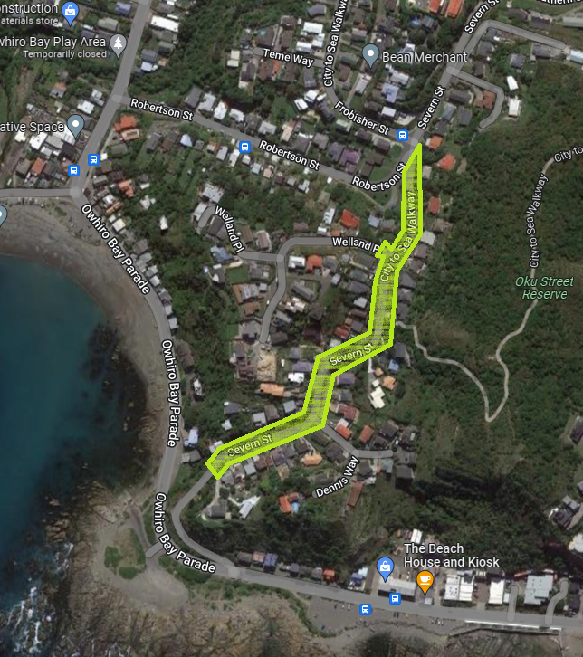
First pre-seal work area
Severn Street

Frobisher/Robertson intersection towards Owhiro Bay Parade

Starting in late July for approximately 10-12 weeks

Exact duration will depend on weather

Contacts
If you have any questions or there is anything we need to be aware of, please contact:

Fulton Hogan
04 387 4852
wccsouth@fultonhogan.com

Wellington City Council
04 499 4444
info@wcc.govt.nz

